**UNIVERSIDAD TECNOLÓGICA DE QUERÉTARO**



5 WHYS AND FISHBONE METHOD FOR

THE DC MOTOR SPEED CONTROLLER

Embedded Software Course

Ugarte, Gabriela

Chavez, Jose Luis

31/10/2019

## 5 Whys

The 5 whys method is a technique used to find the effect-cause relations that a problem generates with the intention of finding the root cause.

For the DC Motor Speed Controller, the 5 Whys method was used in the planning perspective. Along the project was difficult to keep track of the tasks and finish everything according to what was expected to meet the final date.

Description:

1. The release date of the Integrated Project is at risk due to conflicts of activities between the Embedded Software Course at UTEQ and GEIQ. Important releases were done at GEIQ that kept the development team working outside of UTEQ and missing classes during the last few months. This led to missed Sprint activities and a need of time to finish everything as expected.
2. Why was the release date at risk?

It is at risk due to a bad planning

1. Why the planning went wrong?

In the original master schedule, important releases at GEIQ were not contemplated, this led to not sufficient time to develop the DC Motor Speed Controller Project at its finest.

1. Why there was not sufficient time to develop the DC Motor Speed Controller?

The development team is fully committed to the important releases at GEIQ.

1. Why is the development team fully committed to the important releases?

Because the development team is key part of the project.

1. Why is the development team a key part of the project?

Due to the activities that the development team has at GEIQ such as updates, reviews, development, and support to other team members there.

## Fishbone

A fishbone diagram, also called a cause and effect diagram or Ishikawa diagram, is a visualization tool for categorizing the potential causes of a problem in order to identify its root causes. Typically used for root cause analysis, a fishbone diagram combines the practice of brainstorming with a type of mind map template (See Table 1, Table 2, and Figure 1).

Dr. Kaoru Ishikawa, a Japanese quality control expert, is credited with inventing the fishbone diagram to help employees avoid solutions that merely address the symptoms of a much larger problem. Fishbone diagrams are considered one of the seven basic quality tools and are used in the "analyze" phase of Six Sigma's DMAIC (define, measure, analyze, improve, control) approach to problem solving. (Bestefield, 2009)

Description:

1. The release date of the Integrated Project is at risk due to conflicts of activities between the Embedded Software Course at UTEQ and GEIQ. Important releases were done at GEIQ that kept the development team working outside of UTEQ and missing classes during the last few months. This led to missed Sprint activities and a need of time to finish everything as expected.

Main causes:

1. Organization
2. Work
3. Materials

|  |  |
| --- | --- |
| Description | Main Causes |
| It was not planned to have a high workload at GEIQ and important final releases that took longer hours than expected. | Work |
| Work group was reduced from three team members to only two. | Organization |
| Embedded Software Course classes took longer than expected. | Organization |
| The time to dedicate in the project was not enough. | Organization |
| It is needed to work on weekdays besides Friday at the UTEQ. | Work |
| It is needed to invest personal time to understand certain topics in the course. | Work |
| The RENESAS Board cannot be used outside the UTEQ as well as the HW. | Materials |
| The Laboratory use is limited to 2 hours on weekdays in the evening. | Materials |

Table 1. Fishbone Table

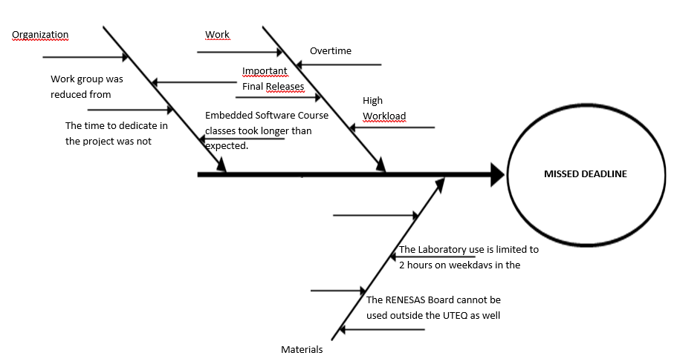

Figure 1. Cause-Effect Fishbone Diagram

|  |  |  |  |
| --- | --- | --- | --- |
| Proposed Actions | Responsible | Revision Date | Fulfilled (Yes, No) |
| Agreed with client a Final Release with exclusions to the project. | Chavez, Jose  Ugarte, Gabriela | 21/10/2019 | Yes |

Table 2. Proposed Actions to mitigate missed deadline